CSA1507-Cloud Computing and Big Data Analytics
Experiment-1
Aim:
Create a simple cloud software application for Car Booking Reservation System using any Cloud Service Provider to demonstrate SaaS include the necessary fields such as search for cabs, from, to, rental , out station, Package type, hours/Days etc.
Procedure:
- Open the Zoho Creator cloud platform and create a new application.
- Create a Car Booking Reservation System application.
- Design a booking form with fields such as:
  - From
  - To
  - Search for Cabs
  - Rental
  - Out Station
  - Package Type
  - Hours / Days
- Add cab details such as Cab Type, Availability, and Fare.
- Configure the form to accept booking details from users.
- Create suitable reports/views to display available cabs and booking information.
- Configure the application to calculate or display the booking and fare details.
- Test the application by entering different source, destination, rental, and package details.
- Publish the application through Zoho Cloud so users can access it through a web browser.
- Demonstrate SaaS by allowing users to use the car booking application online without installing the software locally.

Implementation
Input:
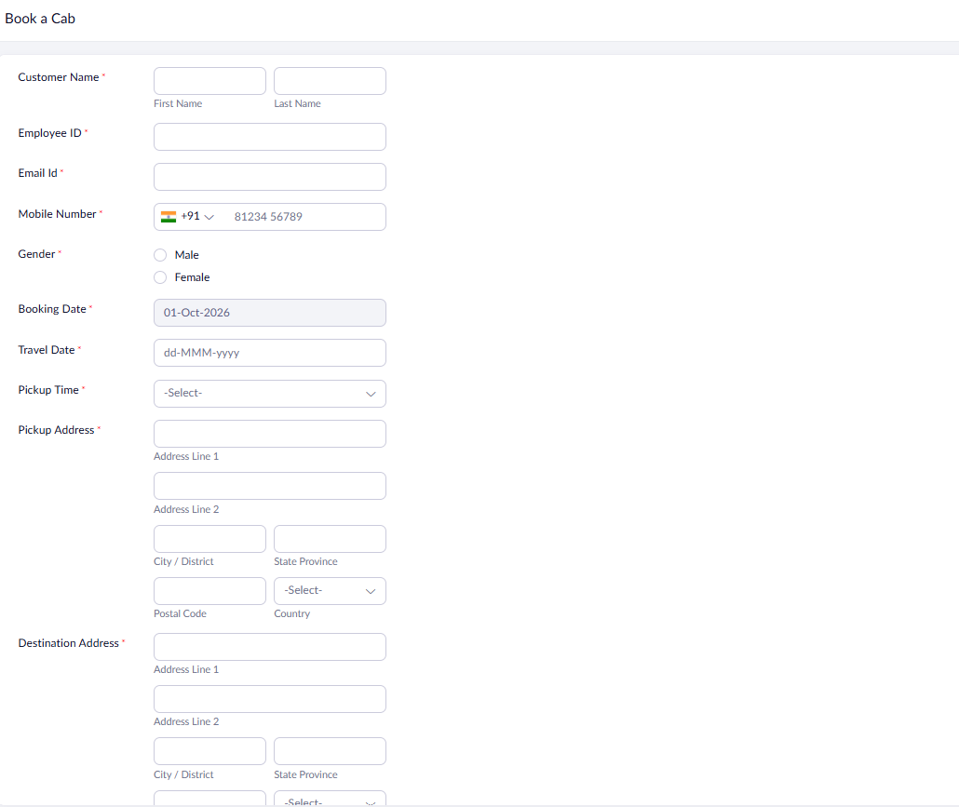

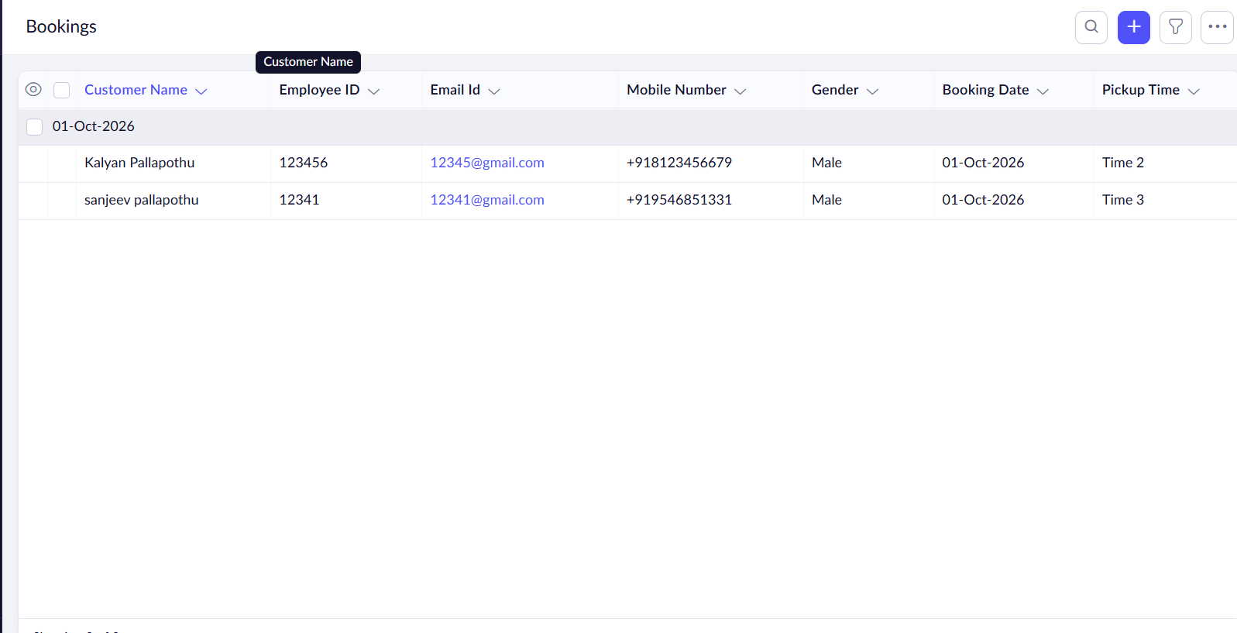

Output:
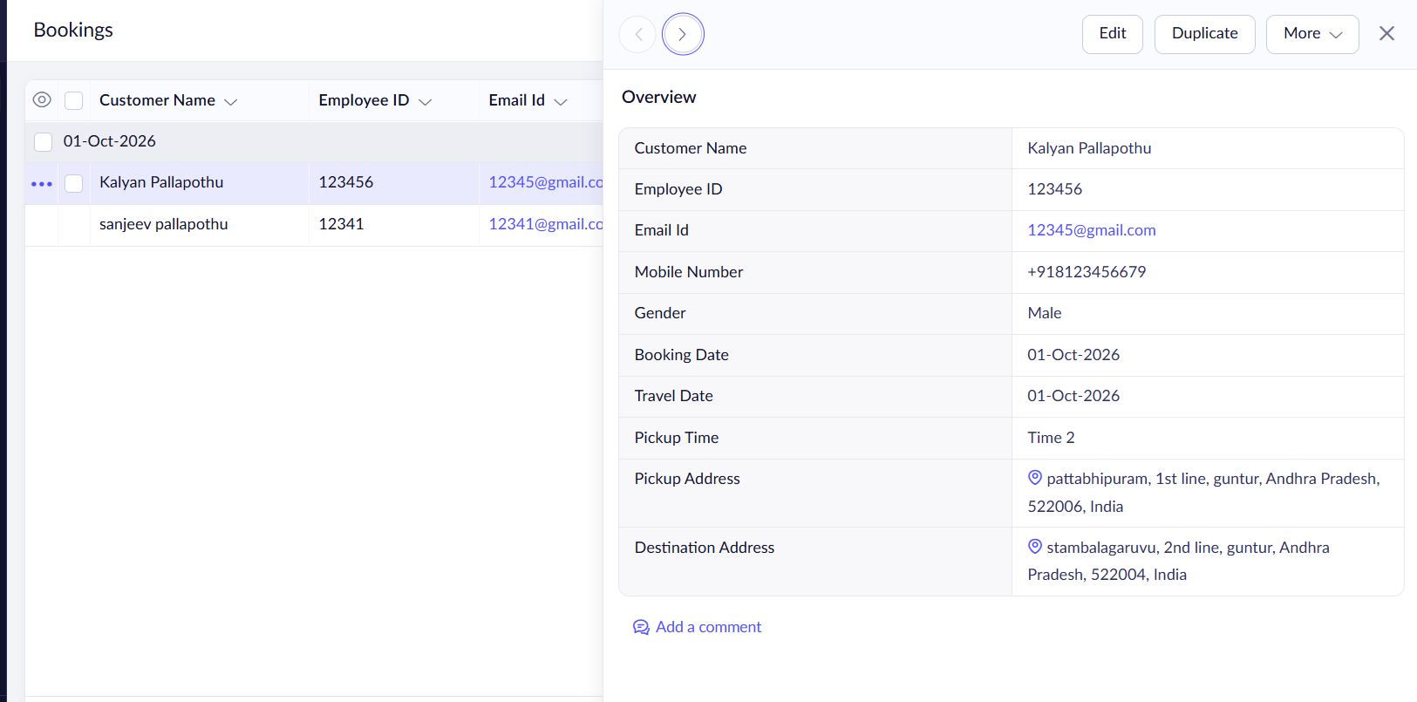

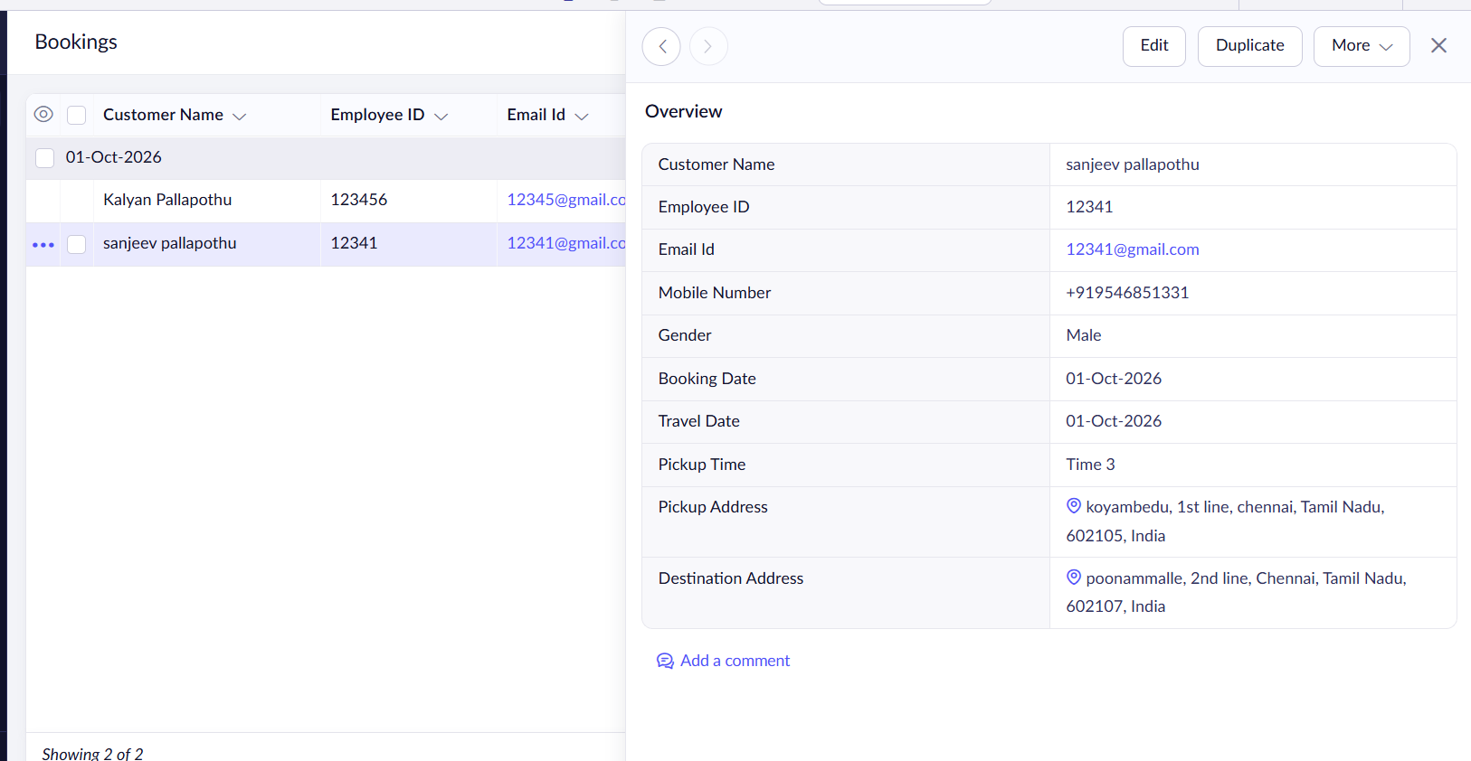

Result:
The Car Booking Reservation System was successfully created and deployed using Zoho Creator as a cloud-based SaaS application. The system allows users to search and book cabs by entering From, To, Rental, Out Station, Package Type, and Hours/Days. The application was tested successfully and accessed through the cloud without requiring local installation.

